Megan Mosier
CSD-325 Module 7
May 3, 2026

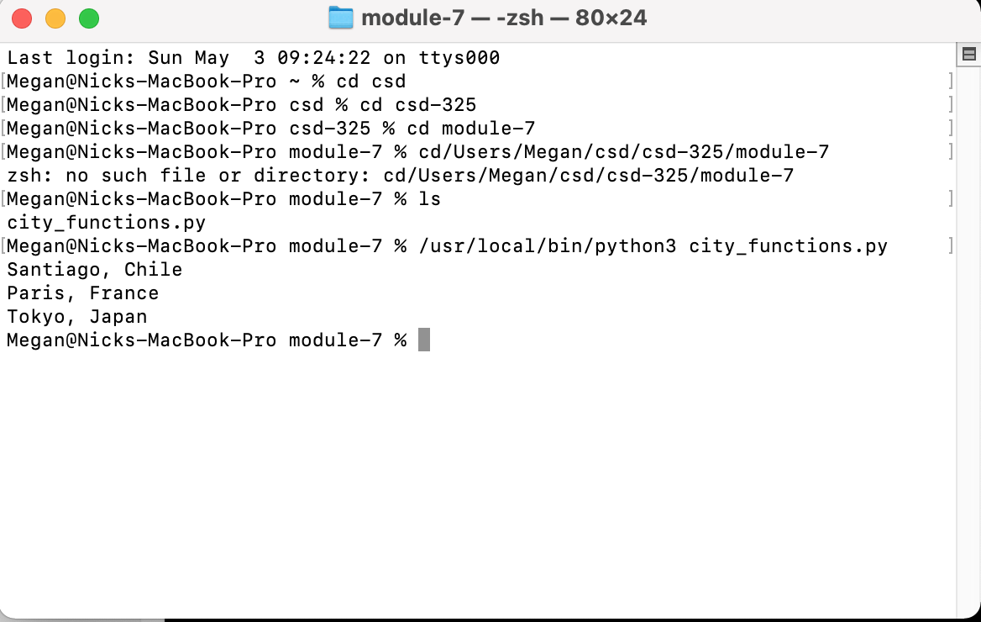
Test_cities run #1
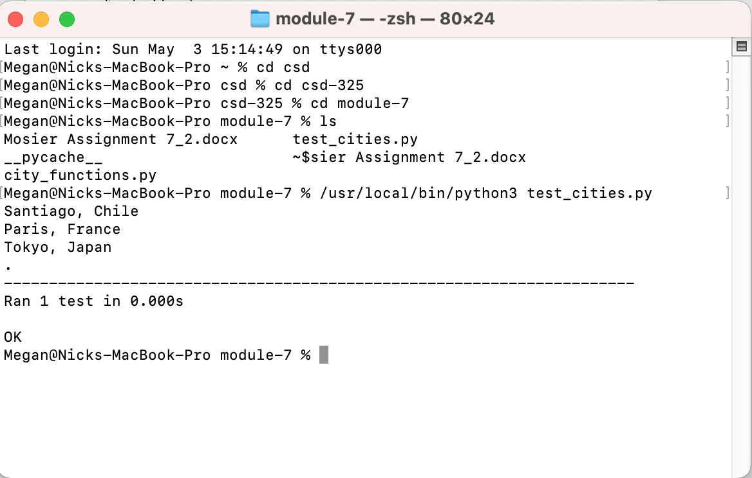
Updating city_functions with populations NOT OPTIONAL
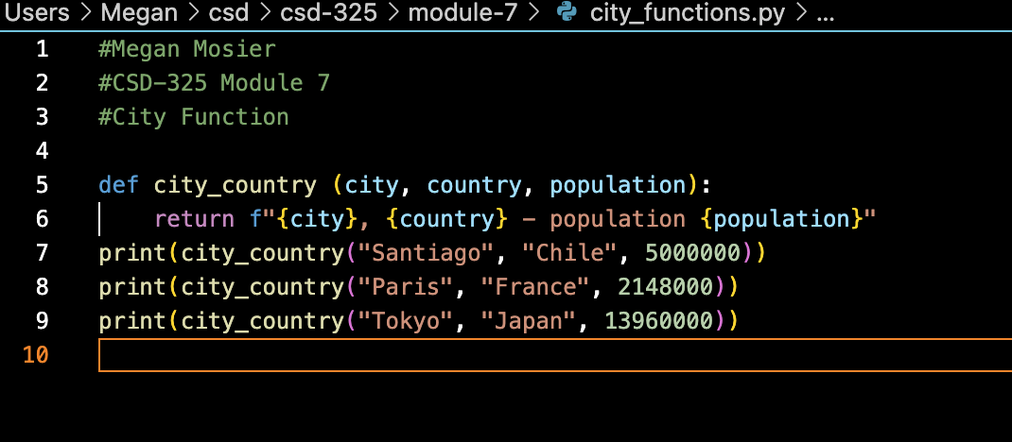

Test fail

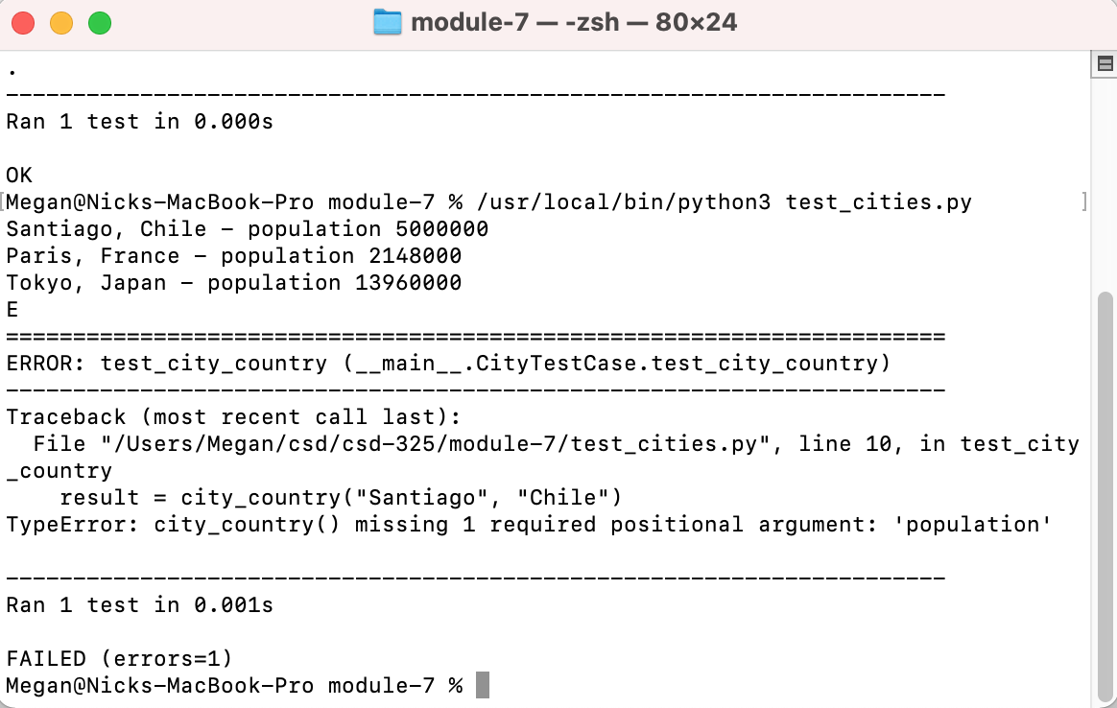

Updated with optional population:
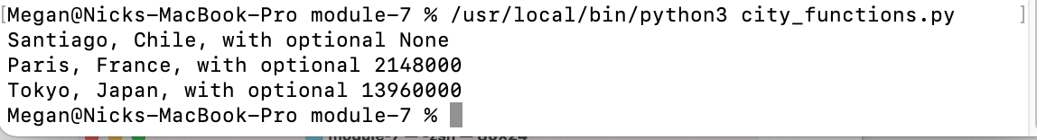

Updated with required language:

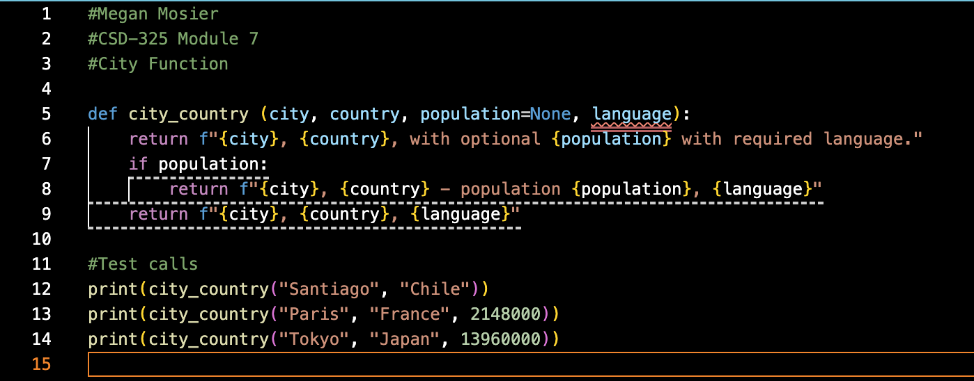
With fail: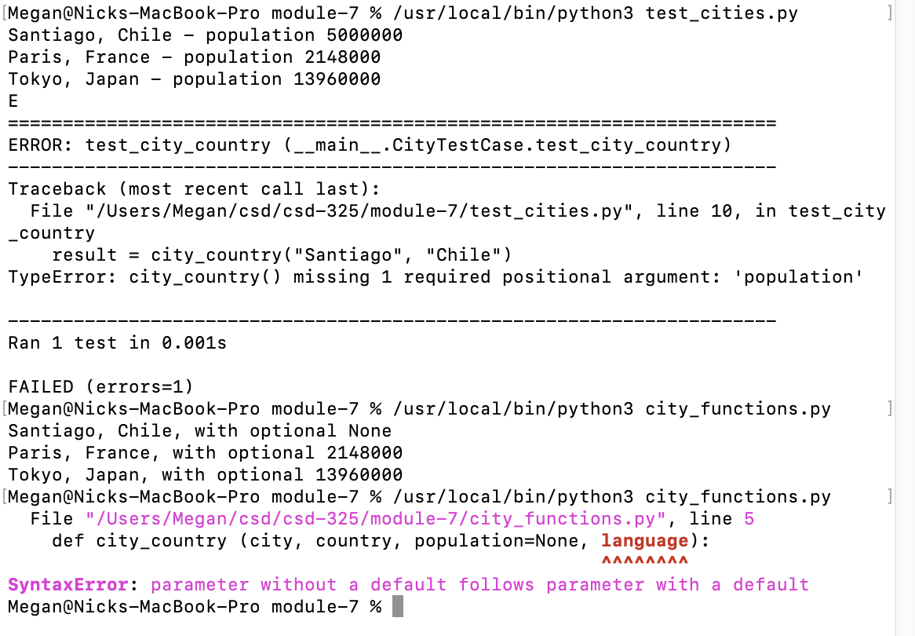

Final result after modifications:

